# Entorno de Desarrollo del curso

**[Visual studio Community 2022(17](https://visualstudio.microsoft.com/es/vs/community/)**[**.3.5)**](https://visualstudio.microsoft.com/es/vs/community/)

**Requerido para instalar en Visual Studio Community 2022:**

**Cargas de trabajo requeridas (las que están seleccionadas)**

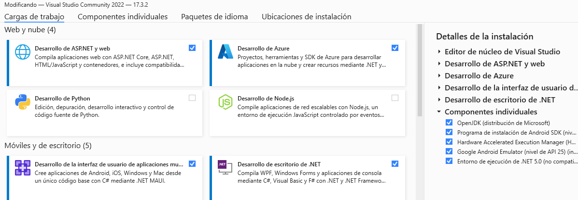

**Add🡪 Desktop Developer C ++**

**Componentes individuales (filtro por palabra Android y verifico que estén seleccionadas las versiones siguientes)**

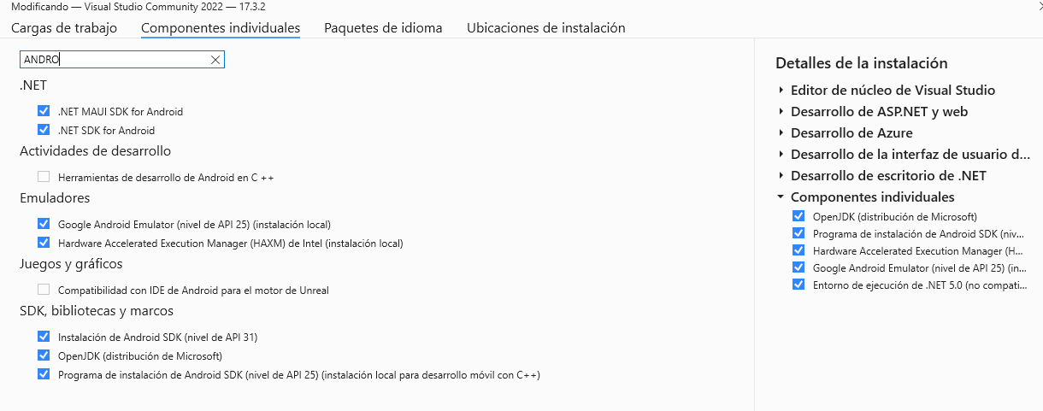

**Paquete del idioma (English) quitar español.**

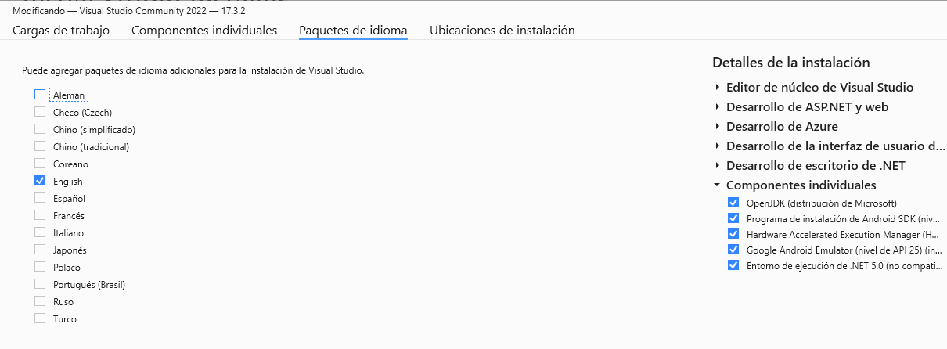

**Programas de instalación requeridos para trabajar con el Front-End con Flutter and Dart**

**Visual Studio Code (última versión)**

* [VSCode](https://code.visualstudio.com/)

**Postman** **(última versión)**

* [Postman](https://www.getpostman.com/downloads/)

**Android Studio (última versión)**

* [Android Studio](https://developer.android.com/studio)

**Flutter SDK**

* [Flutter SDK](https://storage.googleapis.com/flutter_infra_release/releases/stable/windows/flutter_windows_3.0.5-stable.zip)

Emuladores:

[**Vysor**](https://www.vysor.io/)

[**scrcpy (v1.24)**](https://github.com/Genymobile/scrcpy/releases/download/v1.24/scrcpy-win64-v1.24.zip)

# Plugins para instalar dentro visual Studio Code.

* [Awesome Flutter Snippets](https://marketplace.visualstudio.com/items?itemName=Nash.awesome-flutter-snippets)
* [Bracket Pair Colorizer 2](https://marketplace.visualstudio.com/items?itemName=CoenraadS.bracket-pair-colorizer-2)
* [Dart](https://marketplace.visualstudio.com/items?itemName=Dart-Code.dart-code) (plugin en Visual Studio Code plugin)
* [Flutter](https://marketplace.visualstudio.com/items?itemName=Dart-Code.flutter) (plugin en Visual Studio Code plugin)
* [Material Icon Theme](https://marketplace.visualstudio.com/items?itemName=PKief.material-icon-theme)
* [Paste JSON as Code](https://marketplace.visualstudio.com/items?itemName=quicktype.quicktype)
* [Terminal](https://marketplace.visualstudio.com/items?itemName=formulahendry.terminal)
* [Better Comments](https://marketplace.visualstudio.com/items?itemName=aaron-bond.better-comments)
* [Pubspec Assist](https://marketplace.visualstudio.com/items?itemName=jeroen-meijer.pubspec-assist)
* [Monokai Night](https://marketplace.visualstudio.com/items?itemName=fabiospampinato.vscode-monokai-night)

# Configuración del Bracket Pair Colorizer 2

"bracket-pair-colorizer-2.colors": [

"#fafafa",

"#9F51B6",

"#F7C244",

"#F07850",

"#9CDD29",

"#0098FA" ],